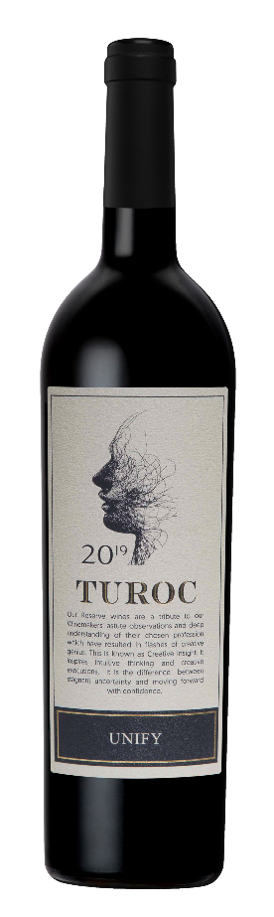
TUROC UNIFY 2019

A well balanced with dominant flavours of cherries, red and blackberries with hints of coriander, clove and white pepper. The wine’s palate displays a well- rounded richness of flavour with bold structures and a long smooth
This vintage is a creative Cape blend showcasing the true reflection of the unique Breedekloof terroir

Origin: Breedekloof, South Africa

Cultivar: Pinotage (34%) Cabernet Sauvignon (33%) Shiraz (33%).

The Concept: Dedication to our winemaker’s choses profession and their creative insight journey. Self-discovery and cultivating intuition and awakening their creative passions to be in a headspace of forward moving motion. The brand name evolved to become TUROC meaning creative, idealistic and virtuous being. The winemaker annually selects premium barrels to unify a limited release blend

Terroir:
Soil: Rocky red soil near Mostertshoek Mountain

Viticulture:
Yield: average 12 Tons/Ha
Trellis System: Two wire extended Perold
Age of Vines: 15 – 20 years
Irrigation: Micro

Analysis:
Alcohol:14.5%
Sugar:2.5g/l
Acid:5.7g/l
pH: 3.53

Oenology:
Harvest Type: Hand picked
Crushing: Destemmed and Crushed
Fermentation: Fermented on skin for 10 – 12 days @ 25°C – 28 °C. 3 Yeast strains were used. VIN13, D254, NT50. Malolactic fermentation completed in 300L barrels

Maturation 22 Months. 75 % French Oak & 25 % American Oak barrels (25% new oak)

